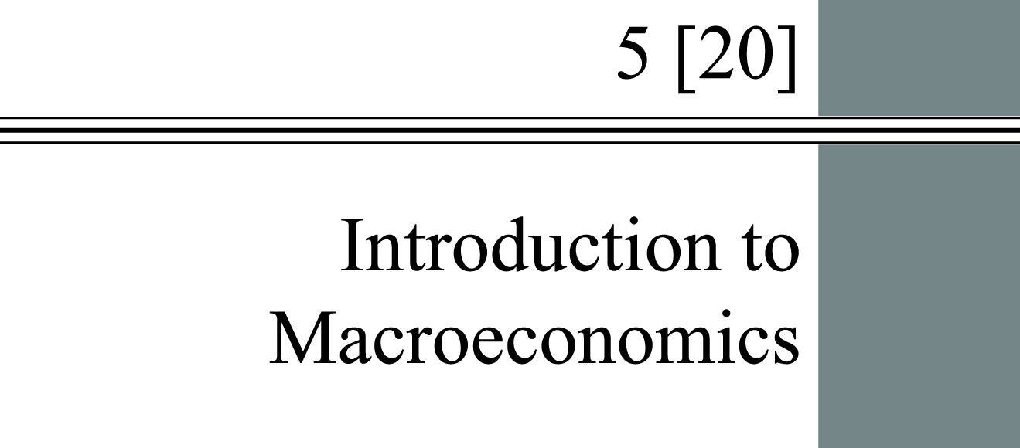

**chapter Outline**

**Macroeconomic Concerns**

Describe the three primary concerns of macroeconomics.

**The Components of the Macroeconomy**

Discuss the interaction between the four components of the macroeconomy.

**A Brief History of Macroeconomics**

Summarize the macroeconomic history of the United States between 1929 and 1970.

**The U.S. Economy Since 1970**

Describe the U.S. economy since 1970.

detailed chapter Outline

I. Introduction

A. *Microeconomics* examines the functioning of individual industries and the behavior of individual decision-making units—that is, firms and households.

B. *Macroeconomics* focuses on the economic behavior of aggregates—income, employment, output, and so on—on a national scale Macroeconomics studies:

1. national income, not household income,

2. the overall price level, not individual prices, and

3. total employment in the economy, not the demand for labor in specific markets.

C. *Aggregate behavior* is the behavior of all households and firms together. GDP is an aggregate. So is national income. Macroeconomists study aggregate consumption and aggregate investment intensively.

D. Macroeconomists observe that important prices in the economy often are “sticky downward.” *Sticky prices* are prices that do not always adjust rapidly to maintain equality between quantity supplied and quantity demanded. That means some prices do not seem to always adjust rapidly to maintain equilibrium in their particular market.

1. The real wage rate is the most notorious example of this. When there is excess supply in the labor market, the real wage falls very slowly. However, the real wage is only “sticky downward.” Real wages rise rapidly when there is excess demand for labor.

2. Other markets may also exhibit sticky prices caused by long-term contracts or other institutional arrangements.

II. Macroeconomic Concerns

A. The three major concerns of macroeconomics are output growth, unemployment, and inflation and deflation.

B. Output Growth

1. A *business cycle*is the cycle of short-term ups and downs in the economy. Economies experience cycles of expansion and contraction.

2. *Aggregate output* is the total quantity of goods and services produced in an economy in a given period. Aggregate output is usually measured by gross domestic product (GDP).

3. A business cycle has four phases:

a. An *expansion* or *boom* is the period in the business cycle from a trough up to a peak during which output and employment grow.

b. A *contraction, recession*,or *slump*is the period in the business cycle from a peak down to a trough during which output and employment fall. A *depression* is a prolonged and deep recession.

c. A peak is the transition from an expansion to a recession.

d. A trough is the transition from a recession to an expansion.

C. Unemployment

1. The *unemployment rate* is the ratio of the number of people unemployed to the total number of people in the labor force. Before you can find work you have to look. People who are not actively seeking employment are not counted as unemployed. They are not in the labor force.

2. Even when an economy is at full employment, there will be some unemployed workers moving between jobs or are spending all their time looking for a job.

3. Unemployment above some minimum level implies the labor market is not in equilibrium. What prevents the market from reaching equilibrium?

D. Inflation and Deflation

1. *Inflation* is an increase in the overall price level. *Hyperinflation* is a period of very rapid increases in the overall price level. The United States is fortunate to never have experienced a hyperinflation. A widely accepted definition of hyperinflation is inflation rates in excess of 50 percent *per month*.

2. *Deflation* is a decrease in the overall price level.

III. The Components of the Macroeconomy

A. There are four major pieces of any macroeconomy.

1. Households.

2. Firms.

3. Government.

4. The rest of the world.

5. Households and firms together make up the private sector. Government is the public sector, and the rest of the world is the foreign sector.

B. The Circular Flow Diagram

1. A *circular flow* diagram shows the flows in and out of the sectors of the economy. This diagram can help you understand how the four pieces of the economy fit together.

a. This diagram illustrates the income received and the payments made by each sector.

b. Households rent their labor to firms and receive wages and salaries as payment. Households also receive interest, dividends, rent, and other payments for factors of production they own.

c. Household receipts include *transfer payments*, cash payments made by the government to people who do not supply goods, services, or labor in exchange for these payments. They include Social Security benefits, veterans’ benefits, and welfare payments.

d. Taken together, these receipts are the total income received by households.

2. Household spending and saving

a. Households spend parts of their income purchasing products from firms. Naturally, some of their income is used to pay taxes.

b. If a household spends less than its income, it *saves* during the period. If a household spends more than its income during a period it *dissaves*. Saving is a “leakage” from the circular flow because it withdraws current purchasing power from the system.

c. Households spend some of their income on *imports*, goods, and services produced in other countries. Households in other countries buy our *exports*, products made here but sold in another country.

3. The government collects taxes from households and firms. The government also purchases goods and services from firms, pays wages and interest to households, and makes transfer payments to households.

4. A very important lesson from the circular flow diagram is that spending creates revenue. When you buy a new computer from Dell, your spending becomes part of Dell’s revenue.

C. The Three Market Arenas

1. Goods-and-Services Markets

a. In the *goods-and-services market*, households and the government purchase goods and services from firms.

b. Firms also purchase goods and services from each other. Most purchases of capital goods are made between firms.

c. The rest of the world, both buys and sells goods and services in this market (international trade including both exports and imports).

d. Households, government, and firms create demand. Firms create the *supply*.

2. Labor Market

a. Interaction in the *labor market* takes place when firms and the government purchase labor from households (demand for labor).

b. Households *supply* the labor.

c. Labor is also supplied to and demanded from the rest of the world.

3. Money Market

a. The *money market* (*financial market*) is where households purchase stocks and bonds from firms. Households *supply* funds expecting they will earn interest and dividends. Households also *demand* (borrow) from this market to finance consumption spending that exceeds their current income. Firms borrow to build plant and equipment, hoping for future profits. Government borrows to finance a deficit. The rest of the world can either lend or borrow.

b. Households purchase common stock from firms and bonds from the government and firms. *Treasury bonds, notes,* and *bills* are promissory notes issued by the federal government when it borrows money. In exchange for money. *Corporate bonds* are promissory notes issued by corporations when they borrow money. *Shares of stock* are financial instruments that give the holder a share in a firm’s ownership and therefore the right to share in the firm’s profits. A *dividend* is the portion of a firm’s profits that the firm pays out each period to its shareholders.

c. Money market activity is coordinated through financial institutions like commercial banks, insurance companies, credit unions, etc.

d. A critical variable in this market is the *interest rate*. Macroeconomics usually assumes there is a single interest rate. In fact, there are many different interest rates in the real world.

D. The Role of the Government in the Macroeconomy

1. *Fiscal policy* is the government’s spending and taxing policies.

a. The federal government collects taxes from households and firms, using the revenue to purchase all manner of goods and services.

b. When the economy is in a recession, the government may use *expansionary fiscal policy*. This involves cutting taxes and/or raising government spending.

c. When the economy is experiencing high growth and inflation, the government may use *contractionary fiscal policy*. This means increasing taxes and/or cutting government spending.

2. Monetary Policy

a. The Federal Reserve is the central bank of the United States. The Fed controls the quantity of money in circulation in the economy.

b. The amount of money in circulation affects the overall price level, interest rates and exchange rates, the unemployment rate, and the level of output.

c. *Monetary policy* includes all the tools used by the Federal Reserve to control the short-term interest rate. Like fiscal policy, monetary policy can be either expansionary or contractionary.

IV. A Brief History of Macroeconomics

A. The Great Depression of the 1930s spurred a great deal of thinking about macroeconomic issues. The *Great Depression* was the period of severe economic contraction and high unemployment that began in 1929 and continued throughout the 1930s.

B. Before 1930, there was no such field as macroeconomics. About the only macroeconomic issue economists were concerned with was the interest rate (Irving Fisher).

C. Classical or market clearing models were the models applied by economists to economywide problems before the Great Depression. Classical economists believed that recessions (downturns in the economy) were self-correcting. The failure of such models to explain the prolonged high unemployment of the Great Depression gave some urgency to the work of economists developing macroeconomic theories (notably John Maynard Keynes).

D. The Keynesian Revolution refers to a new way of looking at the macroeconomy developed by John Maynard Keynes. According to his theory, the level of aggregate demand determines the level of employment. When aggregate demand is low, the economy can become stuck in a recession. Keynes thought the government should increase spending or cut taxes to raise aggregate demand and lift the economy out of the recession.

E. After World War II, Keynes’s views became increasingly influential. The view that government could intervene in the economy to attain specific employment and output goals became firmly established in the United States with the passage of the Employment Act of 1946.

F. During the 1960s economists began to talk about fine tuning the economy. *Fine-tuning* is the phrase used by Walter Heller to refer to the government’s role in regulating inflation and unemployment. Proponents of fine-tuning believed the government could use the tools available to manipulate unemployment and inflation to hit fairly precise targets.

G. During the 1970s and early 1980s “fine tuning” became irrelevant as macroeconomists were forced to substantially revise their models. The economy simply did not behave the way it had before 1970. There was also the vexing problem of *stagflation*, a situation of both high inflation and high unemployment. A combination of the words “stagnation” and “inflation,” this is the term Paul Samuelson coined to describe this era. Consequently, economists and the public lost their faith in the simplified Keynesian model used during the 1950s and 1960s. What had been “conventional wisdom” during the 1960s was largely consigned to the dustheap of failed theories.

V. The U.S. Economy Since 1970

A. Since 1970 the U.S. economy has experienced five recessions and two periods of high inflation.

1. A good deal of macroeconomic data is reported on a quarterly basis. The notation used is the four digit year followed by a space and the Roman numeral for the quarter. Thus 2007 IV is the fourth quarter of 2007.

2. The four recessionary periods were 1974 I–1975 IV,   
1980 II–1983 I, 1990 III–1991 I, 2001 I–2001 III, and   
2008 I–2009 II. The unemployment rate almost always rises during a recession. The highest unemployment rate of this period was 10.7 percent in the fourth quarter of 1982.

3. The two high inflation periods were 1973 IV–1975 IV and   
1979 I–1981 IV. The highest inflation rate was 11.1percent per year in the first quarter of 1975. This was nearly matched by the 10.2 percent rate in 1981 I.

4. Since 1983 both inflation and unemployment have been relatively low. Since 1994 U.S. inflation has been between one and three percent per